Name: Jonel Dominic Tapang Course & Year: BSCS - 3

1. Display all subjects ordered ascendingly by SubCode

[SELECT](http://localhost/phpmyadmin/url.php?url=http://dev.mysql.com/doc/refman/5.5/en/select.html) SubjCode, SubjName FROM ex3subject ORDER BY SubjCode

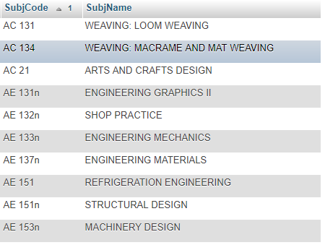

1. Display all Offering (OffNo,ClassType,ClassTime,ClassDay,Room,Units) whose ClassType = 'Lab'

[SELECT](http://localhost/phpmyadmin/url.php?url=http://dev.mysql.com/doc/refman/5.5/en/select.html) OffNo, ClassType, ClassTime, Day, Room, Units FROM ex3Offering WHERE ClassType = 'Lab'

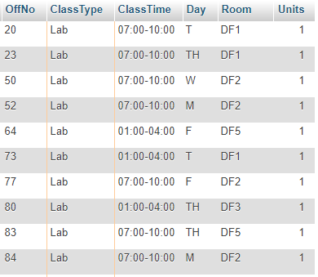

1. Display all Offering (OffNo,ClassType,ClassTime,ClassDay,Room,Units) offered by the department DeptCode = 'DCST'.

[SELECT](http://localhost/phpmyadmin/url.php?url=http://dev.mysql.com/doc/refman/5.5/en/select.html) OffNo, ClassType, ClassTime, Day, Room, Units FROM ex3Offering WHERE DeptCode = 'DCST'

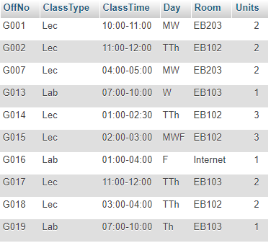

1. Display all Offering (OffNo, SubjCode, SubjName, ClassType,ClassTime,ClassDay,Room,Units) offered by the department with DeptCode = 'DCST'.

[SELECT](http://localhost/phpmyadmin/url.php?url=http://dev.mysql.com/doc/refman/5.5/en/select.html) o.OffNo, o.SubjCode, s.SubjName, o.ClassType, o.ClassTime, o.Day, o.Room, o.Units FROM ex3offering AS o INNER JOIN ex3subject AS s ON o.SubjCode = s.SubjCode WHEREo.DeptCode = 'DCST'

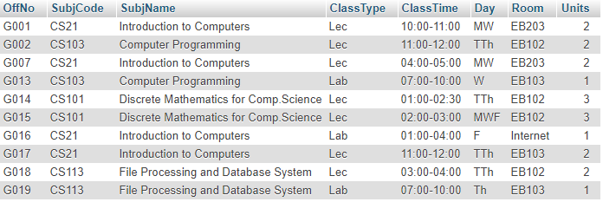

1. Display all Offering (OffNo, SubjCode, SubjName, ClassType,ClassTime,ClassDay,Room,Units, InstName) offered by the department with DeptCode = 'DCST'.

[SELECT](http://localhost/phpmyadmin/url.php?url=http://dev.mysql.com/doc/refman/5.5/en/select.html) o.OffNo, o.SubjCode, s.SubjName, o.ClassType, o.ClassTime, o.Day, o.Room, o.Units, i.InstName FROM ex3offering AS o INNER JOIN ex3subject AS s ON o.SubjCode = s.SubjCodeINNER JOIN ex3instructor as i ON o.InstID = i.InstID WHERE o.DeptCode = 'DCST'

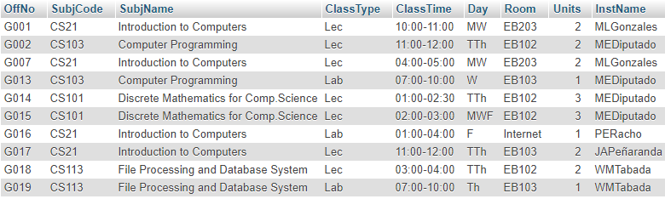

1. Display the classes taught by each instructor (InstName, SubjName, ClassTime, ClassDay, ClassType, Units) arranged by InstName.

[SELECT](http://localhost/phpmyadmin/url.php?url=http://dev.mysql.com/doc/refman/5.5/en/select.html) i.InstName, s.SubjName, o.ClassTime, o.day, o.ClassType, o.Units FROM ex3offering AS o INNER JOIN ex3instructor AS i ON o.InstID = i.InstID INNER JOIN ex3subject as s ONo.SubjCode = s.SubjCode ORDER BY i.InstName

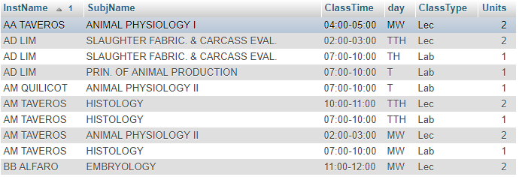

1. Display the classes (InstName, SubjName, ClassTime,ClassDay, ClassType, Units) taught by instructor whose InstName contains the text "TAVEROS". (Hint: use the condition InstName LIKE "%TAVEROS%" in the WHERE clause of SELECT)

[SELECT](http://localhost/phpmyadmin/url.php?url=http://dev.mysql.com/doc/refman/5.5/en/select.html) i.InstName, s.SubjName, o.ClassTime, o.day, o.ClassType, o.Units FROM ex3offering AS o INNER JOIN ex3instructor AS i ON o.InstID = i.InstID INNER JOIN ex3subject as s ONo.SubjCode = s.SubjCode WHERE i.InstName [LIKE](http://localhost/phpmyadmin/url.php?url=http://dev.mysql.com/doc/refman/5.5/en/string-comparison-functions.html#operator_like) "%TAVEROS%"

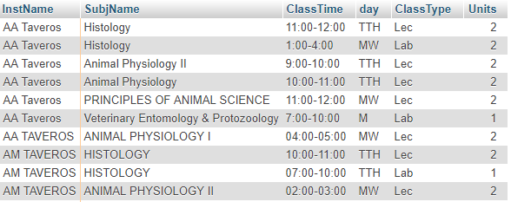

1. Aggregate the total workload units of all Instructors (DeptCode, InstID, InstName, TotalUnits). (Hint : use Sum(Units) as TotalUnits as one of the attributes and then in the Group BY clause include InstID. Example : SELECT SubjCode, Sum(Units) as TotUnits FROM Offering GROUP BY SubjCode)

[SELECT](http://localhost/phpmyadmin/url.php?url=http://dev.mysql.com/doc/refman/5.5/en/select.html) o.DeptCode, o.InstId, i.InstName, [SUM](http://localhost/phpmyadmin/url.php?url=http://dev.mysql.com/doc/refman/5.5/en/group-by-functions.html#function_sum)(o.Units) FROM ex3offering AS o INNER JOIN ex3instructor AS i ON o.InstID = i.InstID GROUP BY i.InstID

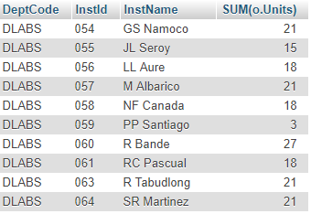

1. Aggregate the number of sections/classes for all subjects (SubjCode, SubjName, NumSections) arranged by SubjCode. (Hint: use count(SubjCode) and then GROUP BY SubjCode)

[SELECT](http://localhost/phpmyadmin/url.php?url=http://dev.mysql.com/doc/refman/5.5/en/select.html) o.SubjCode, s.SubjName, [COUNT](http://localhost/phpmyadmin/url.php?url=http://dev.mysql.com/doc/refman/5.5/en/group-by-functions.html#function_count)(o.SubjCode) FROM ex3offering AS o INNER JOIN ex3subject AS s ON o.SubjCode = s.SubjCode GROUP BY o.SubjCode ORDER BY o.SubjCode

